# SCENARIO #1

This evaluation activity requires you to develop and test a responsive web application in typescript using AngularJS, Bootstrap and a nodejs based front-end development tool set.

The supplied seed project contains a development and test environment that will allow you to start building your app immediately. Unzip the seed project in to a new folder and follow the instructions in the README.md file to get started.

You must address the following requirements:

1. The application needs to display a burger menu so that customers can decide what to order
2. The application needs to be suitable for use on both large devices (desktop and tablet) and small devices (mobile phone)
3. The menu should display a variety of burgers presented as follows:
   * 3 columns of burgers on large devices
   * a single column of burgers on small devices
4. Each burger should be displayed as a visual stack of its elements (eg. bun, cheese, lettuce, tomato, patty etc) styled however you choose (eg. css, icons, images etc)  
     
   The suggested layout is as follows:
   * Title of the burger
   * Visual stack of the burger elements using div, css, image and etc
   * Price of the burger

Please refer to the below screenshot for the UI on large device:

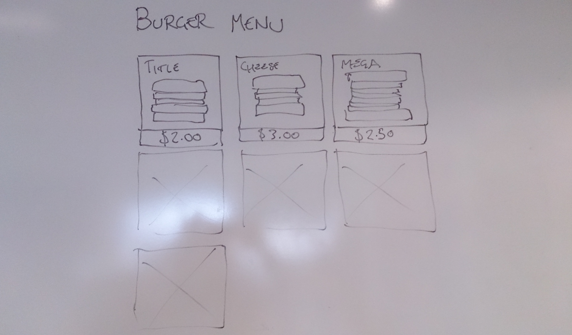

1. Create an angular API service to retrieve the list of burgers including details for each (title, price, burger elements) from an API endpoint. You can decide the endpoint URL and request parameters (if any).

**GET /menu**

Interface Menu   
{   
 menu: Burger[]  
}

Interface Burger   
{   
 title: string,   
    price: number,   
  
 //Possible values: 'BUN', 'BACON', 'CHEESE', 'TOMATO', 'LETTUCE'  
    elements: string[]

}

**Example response**

{

menu: [

{

title: 'Cheeseburger',

price: 2.50,

elements: [

'CHEESE',

'PATTY',

'BUN'

]

},

{

title: 'Megaburger',

price: 5.50,

elements: [

'BUN',

'tomato’

]

}

]

}

1. Mock the API response using the $httpBackend service from angular-mocks instead of connecting to a real API.

**Out of scope**

* The functionality to order burger
* The back-end service that stores the burger information

**Other Requirements**

* Source code must be written in typescript and be strongly typed
* Ensure to test the application manually in chrome, firefox & IE10+
* Unit test line coverage should be a minimum of 80%
* End to end testing should be performed using protractor
* Ensure the application handles any exceptions appropriately